**Decision Tree**

**Example-Fraud Check Dataset**

'data.frame': 600 obs. of 6 variables:

$ Undergrad : Factor w/ 2 levels "NO","YES": 1 2 1 2 1 1 1 2 1 2 ...

$ Marital.Status : Factor w/ 3 levels "Divorced","Married",..: 3 1 2 3 2 1 1 3 3 1 ...

$ Taxable.Income : int 68833 33700 36925 50190 81002 33329 83357 62774 83519 98152 ...

$ City.Population: int 50047 134075 160205 193264 27533 116382 80890 131253 102481 155482 ...

$ Work.Experience: int 10 18 30 15 28 0 8 3 12 4 ...

$ Urban : Factor w/ 2 levels "NO","YES": 2 2 2 2 1 1 2 2 2 2 ...

**In the above data frame 3 variables are factors and rest all are numeric and target variable is Taxable.Income**

**Now we create another variable type, which is factor and contain desired results Good or Risky.**

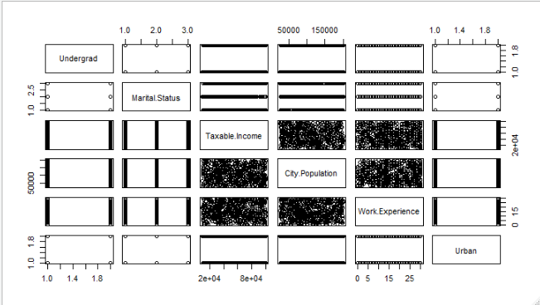

**From the pairs plot, none of variable is correlated with our target variable Taxable.Income and uniform distributed scatter plots between all the numeric variable.**

**Treatment With Imbalanced Data 🡺**

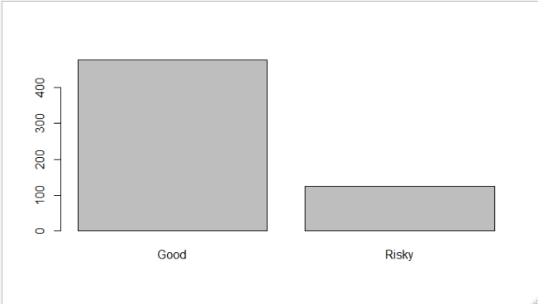

**Good Risky**

**476 124**

**From above plot, our target variable is imbalanced, so we will make ratio equal as 1.**

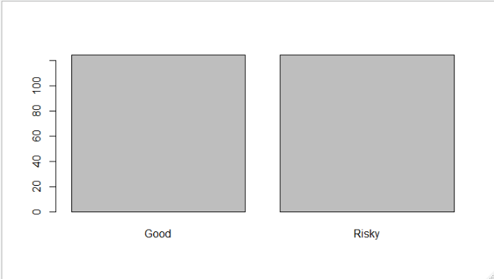

**Now our data is equal in ratio.**

**Model-1 🡺 Using “ctree” function from library “party” with whole data**

**Confusion Matrix**

Actual

Predicted Good Risky

Good 476 124

Risky 0 0

**Accuracy 🡺 0.79333**

**Model-2 🡺 Using “ctree” function from library”party” with balanced data**

**Confusion Matrix**

Actual

Predicted Good Risky

Good 124 124

Risky 0 0

**Accuracy 🡺 0.5**

**Model-3 🡺 Using “ctree” function from library “party” with train data**

**Confusion Matrix**

Predicted

Actual Good Risky

Good 36 0

Risky 1 38

**Accuracy 🡺0.9866**

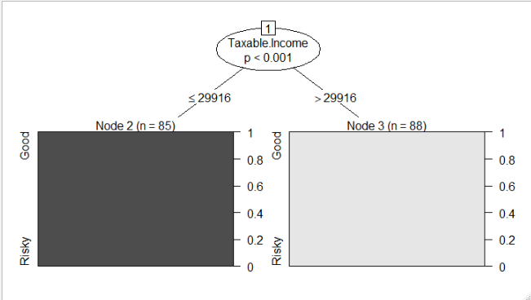

**Whole tree is dependent upon the root node itself i.e Taxable.Income, so this classification model is unreliable.**

**Due to lack of relevant information we can infer that unless and until relevant variable is not introduced then it won’t perform well, so all the classification will be biased to one side.**